



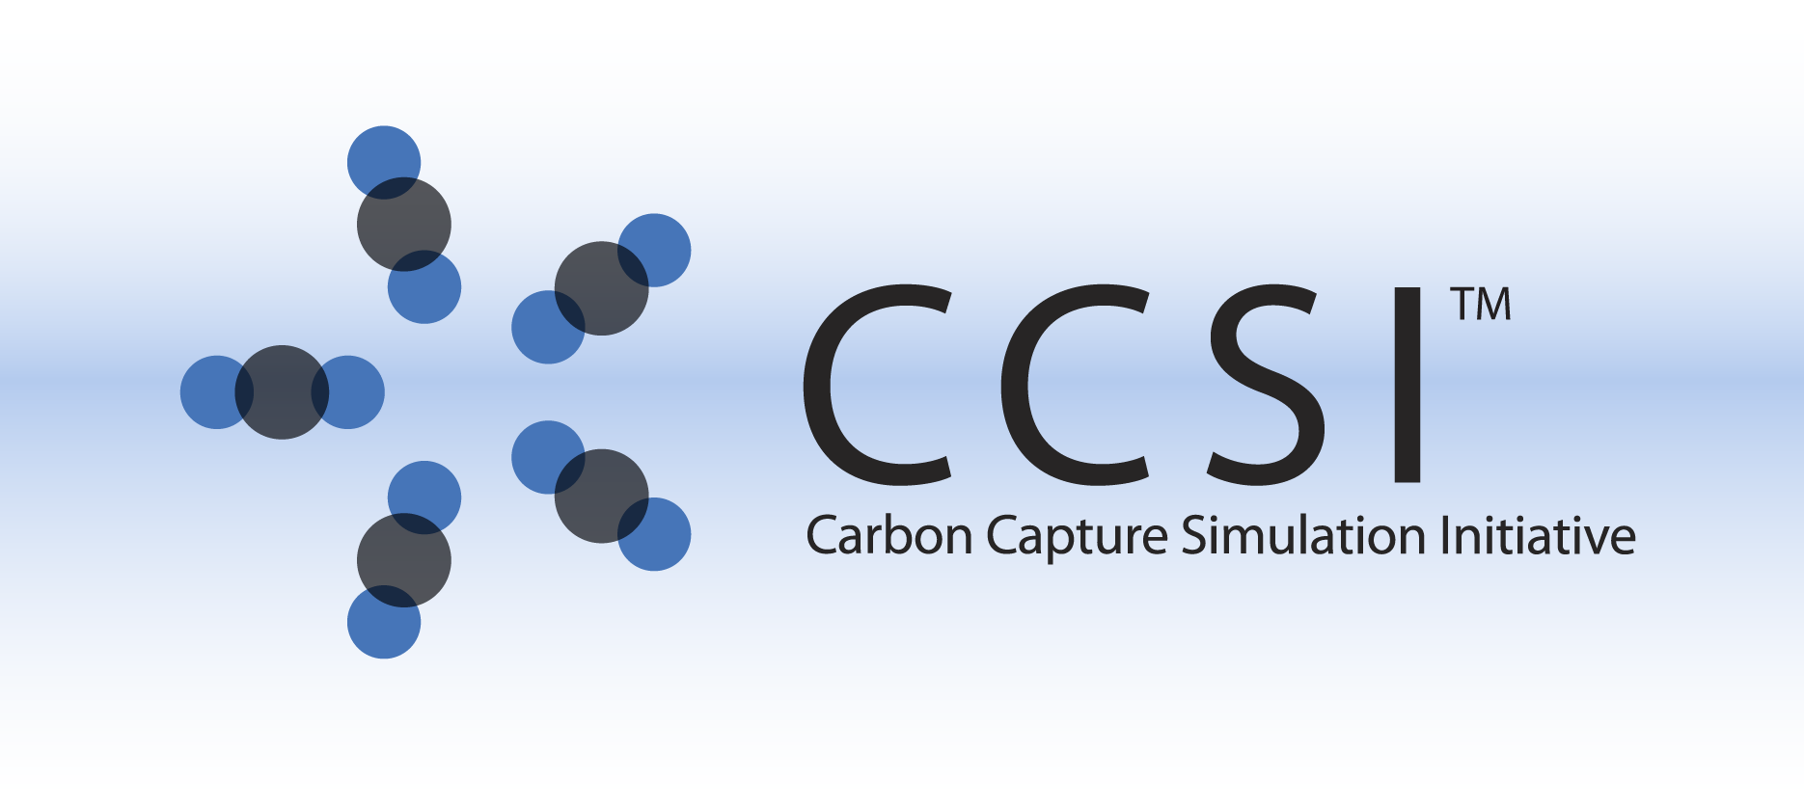

CCSI MEA Dynamic Model

(MEA_dm)

User Manual

Version 2.0.0

March 2018

Copyright (c) 2012 - 2018

**Copyright Notice**

MEA Dynamic Model was produced under the DOE Carbon Capture Simulation Initiative (CCSI), and is copyright (c) 2012 - 2018 by the software owners: Oak Ridge Institute for Science and Education (ORISE), Los Alamos National Security, LLC., Lawrence Livermore National Security, LLC., The Regents of the University of California, through Lawrence Berkeley National Laboratory, Battelle Memorial Institute, Pacific Northwest Division through Pacific Northwest National Laboratory, Carnegie Mellon University, West Virginia University, Boston University, the Trustees of Princeton University, The University of Texas at Austin, URS Energy & Construction, Inc., et al.. All rights reserved.

NOTICE. This Software was developed under funding from the U.S. Department of Energy and the U.S. Government consequently retains certain rights. As such, the U.S. Government has been granted for itself and others acting on its behalf a paid-up, nonexclusive, irrevocable, worldwide license in the Software to reproduce, distribute copies to the public, prepare derivative works, and perform publicly and display publicly, and to permit other to do so.

**License Agreement**

MEA Dynamic Model Copyright (c) 2012 - 2018, by the software owners: Oak Ridge Institute for Science and Education (ORISE), Los Alamos National Security, LLC., Lawrence Livermore National Security, LLC., The Regents of the University of California, through Lawrence Berkeley National Laboratory, Battelle Memorial Institute, Pacific Northwest Division through Pacific Northwest National Laboratory, Carnegie Mellon University, West Virginia University, Boston University, the Trustees of Princeton University, The University of Texas at Austin, URS Energy & Construction, Inc., et al. All rights reserved.

Redistribution and use in source and binary forms, with or without modification, are permitted provided that the following conditions are met:

1. Redistributions of source code must retain the above copyright notice, this list of conditions and the following disclaimer.
2. Redistributions in binary form must reproduce the above copyright notice, this list of conditions and the following disclaimer in the documentation and/or other materials provided with the distribution.
3. Neither the name of the Carbon Capture Simulation Initiative, U.S. Dept. of Energy, the National Energy Technology Laboratory, Oak Ridge Institute for Science and Education (ORISE), Los Alamos National Security, LLC., Lawrence Livermore National Security, LLC., the University of California, Lawrence Berkeley National Laboratory, Battelle Memorial Institute, Pacific Northwest National Laboratory, Carnegie Mellon University, West Virginia University, Boston University, the Trustees of Princeton University, the University of Texas at Austin, URS Energy & Construction, Inc., nor the names of its contributors may be used to endorse or promote products derived from this software without specific prior written permission.

THIS SOFTWARE IS PROVIDED BY THE COPYRIGHT HOLDERS AND CONTRIBUTORS "AS IS" AND ANY EXPRESS OR IMPLIED WARRANTIES, INCLUDING, BUT NOT LIMITED TO, THE IMPLIED WARRANTIES OF MERCHANTABILITY AND FITNESS FOR A PARTICULAR PURPOSE ARE DISCLAIMED. IN NO EVENT SHALL THE COPYRIGHT OWNER OR CONTRIBUTORS BE LIABLE FOR ANY DIRECT, INDIRECT, INCIDENTAL, SPECIAL, EXEMPLARY, OR CONSEQUENTIAL DAMAGES (INCLUDING, BUT NOT LIMITED TO, PROCUREMENT OF SUBSTITUTE GOODS OR SERVICES; LOSS OF USE, DATA, OR PROFITS; OR BUSINESS INTERRUPTION) HOWEVER CAUSED AND ON ANY THEORY OF LIABILITY, WHETHER IN CONTRACT, STRICT LIABILITY, OR TORT (INCLUDING NEGLIGENCE OR OTHERWISE) ARISING IN ANY WAY OUT OF THE USE OF THIS SOFTWARE, EVEN IF ADVISED OF THE POSSIBILITY OF SUCH DAMAGE.

You are under no obligation whatsoever to provide any bug fixes, patches, or upgrades to the features, functionality or performance of the source code ("Enhancements") to anyone; however, if you choose to make your Enhancements available either publicly, or directly to Lawrence Berkeley National Laboratory, without imposing a separate written license agreement for such Enhancements, then you hereby grant the following license: a non-exclusive, royalty-free perpetual license to install, use, modify, prepare derivative works, incorporate into other computer software, distribute, and sublicense such enhancements or derivative works thereof, in binary and source code form. This material was produced under the DOE Carbon Capture Simulation

Table of Contents

CCSI Process Models Error! Bookmark not defined.

1.0 Abstract **Error! Bookmark not defined.**

2.0 Reporting Issues 1

3.0 Version Log 1

Solid Sorbent Process Models Error! Bookmark not defined.

Bubbling Fluidized Bed (BFB) Error! Bookmark not defined.

1.0 Introduction **Error! Bookmark not defined.**

2.0 General Information **Error! Bookmark not defined.**

2.1 Overview **Error! Bookmark not defined.**

2.2 Model Assumptions **Error! Bookmark not defined.**

2.3 Liquid Density of Water **Error! Bookmark not defined.**

3.0 Model Structure **Error! Bookmark not defined.**

3.1 IO Structure and Reactor Dimensions **Error! Bookmark not defined.**

3.2 Run Mode Selectors **Error! Bookmark not defined.**

3.3 Component List and Physical Properties **Error! Bookmark not defined.**

3.4 Pressure Drop **Error! Bookmark not defined.**

3.5 Three-Region Mass and Energy Balances **Error! Bookmark not defined.**

3.6 Hydrodynamics **Error! Bookmark not defined.**

3.7 Heat Exchanger Model **Error! Bookmark not defined.**

4.0 Tutorial **Error! Bookmark not defined.**

4.1 Pre-Solved Cases **Error! Bookmark not defined.**

4.2 Model Inputs **Error! Bookmark not defined.**

4.3 ACM Implementation **Error! Bookmark not defined.**

4.4 gPROMS Implementation **Error! Bookmark not defined.**

5.0 Discretisation Study **Error! Bookmark not defined.**

5.1 Study Conditions **Error! Bookmark not defined.**

5.2 Summary **Error! Bookmark not defined.**

6.0 Changing Reaction Kinetics **Error! Bookmark not defined.**

7.0 Installation Requirements **Error! Bookmark not defined.**

8.0 References **Error! Bookmark not defined.**

BFB-D-ROM Error! Bookmark not defined.

1.0 Introduction **Error! Bookmark not defined.**

2.0 Methodology **Error! Bookmark not defined.**

3.0 Test Tutorial **Error! Bookmark not defined.**

3.1 Dynamic Simulation **Error! Bookmark not defined.**

3.2 Comparison of Simulation Cost and Accuracy **Error! Bookmark not defined.**

4.0 References **Error! Bookmark not defined.**

Moving Bed Error! Bookmark not defined.

1.0 Introduction **Error! Bookmark not defined.**

2.0 General Information **Error! Bookmark not defined.**

2.1 Overview **Error! Bookmark not defined.**

2.2 Model Assumptions **Error! Bookmark not defined.**

3.0 Model Structure **Error! Bookmark not defined.**

3.1 IO Structure and Reactor Dimensions **Error! Bookmark not defined.**

3.2 Component List and Physical Properties **Error! Bookmark not defined.**

3.3 Mass Balance and Pressure Drop **Error! Bookmark not defined.**

3.4 Energy Balance **Error! Bookmark not defined.**

3.5 Initialization Strategy **Error! Bookmark not defined.**

3.6 Other Features **Error! Bookmark not defined.**

4.0 Tutorial **Error! Bookmark not defined.**

4.1 Steady-State Model **Error! Bookmark not defined.**

4.2 Dynamic Model **Error! Bookmark not defined.**

4.3 Implementation of Model in gPROMS **Error! Bookmark not defined.**

5.0 Installation Requirements **Error! Bookmark not defined.**

6.0 Reference **Error! Bookmark not defined.**

Integrated Solid Sorbent CO2 Capture System Model Error! Bookmark not defined.

1.0 Introduction **Error! Bookmark not defined.**

2.0 Integrated Model Structure **Error! Bookmark not defined.**

2.1 IO Structure **Error! Bookmark not defined.**

2.2 Component List and Physical Properties **Error! Bookmark not defined.**

3.0 ACM Integrated Model Tutorial **Error! Bookmark not defined.**

4.0 Implementation of Integrated Model in gPROMS **Error! Bookmark not defined.**

5.0 Installation Requirements **Error! Bookmark not defined.**

6.0 Reference **Error! Bookmark not defined.**

Solvent Process Models Error! Bookmark not defined.

MEA Steady State Model Error! Bookmark not defined.

1.0 Model Development **Error! Bookmark not defined.**

1.1 Model Background **Error! Bookmark not defined.**

1.2 Physical Property Models **Error! Bookmark not defined.**

1.3 Mass Transfer and Hydraulic Models **Error! Bookmark not defined.**

1.4 Development of Process Model **Error! Bookmark not defined.**

1.5 Model Features **Error! Bookmark not defined.**

2.0 Tutorial **Error! Bookmark not defined.**

2.1 Predicting System VLE **Error! Bookmark not defined.**

2.2 CO2 Capture Process Simulation Base Case Setup **Error! Bookmark not defined.**

2.3 CO2 Capture Process Simulation Example **Error! Bookmark not defined.**

3.0 Usage Information **Error! Bookmark not defined.**

3.1 Environment/Prerequisites **Error! Bookmark not defined.**

3.2 Support **Error! Bookmark not defined.**

4.0 References **Error! Bookmark not defined.**

MEA Dynamic Model 2

1.0 Model Background 2

2.0 General Information 2

2.1 Overview 2

2.2 Thermodynamic Properties Package 3

2.3 Controllers Configuration 4

3.0 Tutorial 5

3.1 Reaching an Initial Steady-State 5

3.2 CO2 Capture Dynamic Response Simulation 9

4.0 Reference 10

2-MPZ Model Error! Bookmark not defined.

1.0 Introduction **Error! Bookmark not defined.**

1.1 Predicting CO2 Solubility **Error! Bookmark not defined.**

1.2 Features List **Error! Bookmark not defined.**

2.0 Tutorial **Error! Bookmark not defined.**

2.1 Absorber Simulation **Error! Bookmark not defined.**

2.2 Stripper Simulation **Error! Bookmark not defined.**

3.0 Usage Information **Error! Bookmark not defined.**

3.1 Environment/Prerequisites **Error! Bookmark not defined.**

3.2 Support **Error! Bookmark not defined.**

3.3 Restrictions **Error! Bookmark not defined.**

3.4 Next Steps **Error! Bookmark not defined.**

4.0 Debugging **Error! Bookmark not defined.**

4.1 How to Debug **Error! Bookmark not defined.**

4.2 Known Issues **Error! Bookmark not defined.**

4.3 Reporting Issues **Error! Bookmark not defined.**

5.0 Model History **Error! Bookmark not defined.**

5.1 Thermodynamic Model **Error! Bookmark not defined.**

5.2 Kinetic Model **Error! Bookmark not defined.**

6.0 References **Error! Bookmark not defined.**

Solvent Crossflow Heat Exchanger Error! Bookmark not defined.

1.0 Installation Requirements **Error! Bookmark not defined.**

2.0 Introduction **Error! Bookmark not defined.**

2.1 Features List **Error! Bookmark not defined.**

3.0 Tutorial **Error! Bookmark not defined.**

3.1 Setup: Property Sets **Error! Bookmark not defined.**

3.2 Setup: Flowsheet **Error! Bookmark not defined.**

3.3 Setup: Calculator Blocks **Error! Bookmark not defined.**

3.4 Setup: Optimization Block **Error! Bookmark not defined.**

3.5 Running the Simulation **Error! Bookmark not defined.**

4.0 Usage Information **Error! Bookmark not defined.**

4.1 Support **Error! Bookmark not defined.**

4.2 Restrictions **Error! Bookmark not defined.**

4.3 Known Issues **Error! Bookmark not defined.**

5.0 Debugging **Error! Bookmark not defined.**

5.1 How to Debug **Error! Bookmark not defined.**

5.2 Reporting Issues **Error! Bookmark not defined.**

6.0 Model History **Error! Bookmark not defined.**

6.1 Block Descriptions **Error! Bookmark not defined.**

7.0 References **Error! Bookmark not defined.**

Other Process Models Error! Bookmark not defined.

Membrane Model Error! Bookmark not defined.

1.0 Introduction **Error! Bookmark not defined.**

2.0 General Information **Error! Bookmark not defined.**

2.1 Overview **Error! Bookmark not defined.**

2.2 System/Installation Requirements **Error! Bookmark not defined.**

2.3 Model Assumptions **Error! Bookmark not defined.**

3.0 Model Structure **Error! Bookmark not defined.**

3.1 IO Structure and Reactor Dimensions **Error! Bookmark not defined.**

3.2 Membrane Transport Model **Error! Bookmark not defined.**

3.3 Membrane Module Model **Error! Bookmark not defined.**

3.4 Hollow Fiber Module Properties **Error! Bookmark not defined.**

4.0 Tutorial **Error! Bookmark not defined.**

5.0 References **Error! Bookmark not defined.**

Compressor Model Error! Bookmark not defined.

1.0 Introduction **Error! Bookmark not defined.**

2.0 Compressor Stage Calculations **Error! Bookmark not defined.**

2.1 Dimensionless Numbers **Error! Bookmark not defined.**

2.2 Efficiency **Error! Bookmark not defined.**

2.3 Constraints **Error! Bookmark not defined.**

3.0 Multi-Stage Compressors **Error! Bookmark not defined.**

3.1 Integral Gear **Error! Bookmark not defined.**

3.2 Inline **Error! Bookmark not defined.**

4.0 TEG CO2 Drier **Error! Bookmark not defined.**

5.0 Property Methods **Error! Bookmark not defined.**

5.1 Compression **Error! Bookmark not defined.**

5.2 Drying, Aspen Properties **Error! Bookmark not defined.**

6.0 ACM Model **Error! Bookmark not defined.**

6.1 Compressor Stage Calculations **Error! Bookmark not defined.**

6.2 Intercoolers **Error! Bookmark not defined.**

6.3 Multistage Compressor Models **Error! Bookmark not defined.**

6.4 Multistage Flash Model **Error! Bookmark not defined.**

6.5 Integral Gear Compressor with Drier Simulation **Error! Bookmark not defined.**

6.6 Inline Compressor with Drier Simulation **Error! Bookmark not defined.**

7.0 Results **Error! Bookmark not defined.**

7.1 Validation **Error! Bookmark not defined.**

7.2 Results for Typical Feed **Error! Bookmark not defined.**

8.0 Dynamic Simulations **Error! Bookmark not defined.**

8.1 Performance Curves **Error! Bookmark not defined.**

8.2 Surge Line **Error! Bookmark not defined.**

9.0 References **Error! Bookmark not defined.**

List of Figures

Figure 1: BFB reactor model schematic. **Error! Bookmark not defined.**

Figure 2: Three-region structure mass transfer schematic. **Error! Bookmark not defined.**

Figure 3: Classification of the BFB models. **Error! Bookmark not defined.**

Figure 4: Model Forms menu in ACM. **Error! Bookmark not defined.**

Figure 5: Flowsheet LocalVariables in ACM. **Error! Bookmark not defined.**

Figure 6: Changing simulation run mode in ACM. **Error! Bookmark not defined.**

Figure 7: gPROMS explorer and flowsheet model. **Error! Bookmark not defined.**

Figure 8: gPROMS model parameter input. **Error! Bookmark not defined.**

Figure 9: gPROMS flowsheet variable input parameter specification interface. **Error! Bookmark not defined.**

Figure 10: gPROMS “Simulate” window. **Error! Bookmark not defined.**

Figure 11: gPROMS simulation results tree. **Error! Bookmark not defined.**

Figure 12: Dependence of CO2 removal on number of discretization points. **Error! Bookmark not defined.**

Figure 13: Dependence of predicted inlet pressure on number of discretization points. **Error! Bookmark not defined.**

Figure 14: Dynamics of percent CO2 removed for disturbances in flue gas flowrate, temperature, and solid temperature. **Error! Bookmark not defined.**

Figure 15: Dynamics of sorbent loading for disturbances in flue gas flowrate, temperature, and solid temperature. **Error! Bookmark not defined.**

Figure 16: Schematic of the MB reactor. **Error! Bookmark not defined.**

Figure 17: Temperature profile plot. **Error! Bookmark not defined.**

Figure 18: Gas composition profile plot. **Error! Bookmark not defined.**

Figure 19: Exit solid sorbent loading after ramp in solid sorbent flowrate. **Error! Bookmark not defined.**

Figure 20: Specification box for MB model. The process flowsheet model “process_MB” is highlight in the “project tree” menu on the left. **Error! Bookmark not defined.**

Figure 21: Click “Play” (the green button on the top of the toolbar) while the “process_MB Model” window is open to open the “Simulate” window. The “Initialisation Procedure” drop-down menu enables the user the option to run the initialization procedure. Select the “Ignore schedule and intrinsic tasks” check box to run a steady-state model. **Error! Bookmark not defined.**

Figure 22: After a simulation begins, the “Results” folder displays at the end of the “project tree.” Navigate to the “Trajectories” → “Flowsheet” → “MB” → “Variables” folder to examine the results of a successful simulation. **Error! Bookmark not defined.**

Figure 23: Steady-state profile of component solid flow through the reactor. **Error! Bookmark not defined.**

Figure 24: Dynamic profile of physiorbed H2O solid flow through the reactor from a simulated ramp in the inlet solid temperature. **Error! Bookmark not defined.**

Figure 25: Gas flowrate to compressors. **Error! Bookmark not defined.**

Figure 26: Percent CO2 removed from the flue gas during step changes. **Error! Bookmark not defined.**

Figure 27: Power requirement of CO2 compressors during step changes. **Error! Bookmark not defined.**

Figure 28: Specification box for MB model. The process flowsheet model “Integrated_process” is highlighted in the “project tree” menu on the left. **Error! Bookmark not defined.**

Figure 29: Click “Play” (the green arrow on the top toolbar) while the “process_MB Model” window is open to open the “Simulate” window. The “Initialisation Procedure” drop-down menu enables the user the option to run the initialization procedure. Select the “Ignore” option. **Error! Bookmark not defined.**

Figure 30: Data selection window for gRMS template. **Error! Bookmark not defined.**

Figure 31: A plot that results from loading template “stage12.gpt.” This plot shows the dynamic power requirements of the stage 1 and stage 2 compressor. Note: The data will be added as the simulation to continue, therefore the generated plot may contain more or less time series data than is shown here. **Error! Bookmark not defined.**

Figure 32: gPROMS simulation power requirement for CO2 compressors during ramped decrease in flue gas. **Error! Bookmark not defined.**

Figure 33: gPROMS simulation inlet flue gas flowrate and percent CO2 removed. **Error! Bookmark not defined.**

Figure 34: CO2 partial pressure as a function of loading and temperature (30 wt% MEA). **Error! Bookmark not defined.**

Figure 35: Setup of the “FLOW” sensitivity block for the case study. **Error! Bookmark not defined.**

Figure 36: Results of the “FLOW” sensitivity block for the case study. **Error! Bookmark not defined.**

Figure 37: Absorber temperature profile for the case study. **Error! Bookmark not defined.**

Figure 38: Regenerator temperature profile for the case study. **Error! Bookmark not defined.**

Figure 39: Equilibrium model and rate-based model comparison. 3

Figure 40: “LeanSolvent_FC” configuration window. 5

Figure 41: Opening a form. 6

Figure 42: Run options. 7

Figure 43: Lean solvent flowrate behavior during step change to a new steady-state. 8

Figure 44: Lean solvent flowrate behavior during step change to a new steady-state (0.5 h). 8

Figure 45: Lean solvent flowrate into absorber. 9

Figure 46: CO2 capture percentage. 10

Figure 47: CO2 solubility in 8 m 2MPZ. **Error! Bookmark not defined.**

Figure 48: A simple absorber. **Error! Bookmark not defined.**

Figure 49: Excerpt of stream results. **Error! Bookmark not defined.**

Figure 50: Design specification REMOVAL results. **Error! Bookmark not defined.**

Figure 51: Packed column rating results. **Error! Bookmark not defined.**

Figure 52: Stripper simulation flowsheet. **Error! Bookmark not defined.**

Figure 53: Excerpt of stream results. **Error! Bookmark not defined.**

Figure 54: The design specification results. **Error! Bookmark not defined.**

Figure 55: Excerpt from packed column rating results. **Error! Bookmark not defined.**

Figure 56: Thermodynamic heat of absorption of 8 m 2MPZ calculated from Equation 1. **Error! Bookmark not defined.**

Figure 57: Calorimetric heat of absorption of 8 m 2MPZ calculated from Equation 2. **Error! Bookmark not defined.**

Figure 58: The absolute differences between the two heat of absorption calculations, which agree well until a loading of 0.25 mol CO2/mol alkalinity, where the zwitterion becomes significant. **Error! Bookmark not defined.**

Figure 59: WWC process flow diagram for Aspen Plus. **Error! Bookmark not defined.**

Figure 60: Boundary layer discretization. The x-axis is fraction through the boundary layer with the gas-liquid interface at left and the bulk liquid at right. **Error! Bookmark not defined.**

Figure 61: Brønsted plot showing the reaction rate constant (kAm-b) versus the pKa of a base for an amine catalyzed by a base, kAm-base. **Error! Bookmark not defined.**

Figure 62: 8 m 2MPZ kinetic fit. There is a linear bias with temperature. Filled points represent absorption, open points desorption. Dashed lines delineate the target range ±20%. **Error! Bookmark not defined.**

Figure 63: 8 m 2MPZ kinetic fit. Model flux ratioed to experimental flux shows no clear trend with loading. Filled points represent absorption, open points desorption. The dashed lines delineate the target range ±20%. **Error! Bookmark not defined.**

Figure 64: Linked heater blocks. **Error! Bookmark not defined.**

Figure 65: HFGP membrane device model schematic. **Error! Bookmark not defined.**

Figure 66: Asymmetric membrane. **Error! Bookmark not defined.**

Figure 67: PermeateM2 stream results. **Error! Bookmark not defined.**

Figure 68: RetenateM2 stream results. **Error! Bookmark not defined.**

Figure 69: Maximum Mach number estimates. **Error! Bookmark not defined.**

Figure 70: ACM integral gear with drying flowsheet. **Error! Bookmark not defined.**

Figure 71: CO2 saturated water content, Aspen Properties LK-PLOCK. **Error! Bookmark not defined.**

Figure 72: CO2 saturated water content, Aspen Properties HYSGLYCO. **Error! Bookmark not defined.**

Figure 73: CO2 solubility in TEG, Aspen Properties HYSGLYCO. **Error! Bookmark not defined.**

Figure 74: ACM flowsheet for an integral gear compressor with drier. **Error! Bookmark not defined.**

Figure 75: ACM flowsheet for an inline compressor with drier. **Error! Bookmark not defined.**

Figure 76: Dimensionless performance curves for Stage 1. **Error! Bookmark not defined.**

Figure 77: ACM dynamic simulation example: Ramp change in inlet flow rate, pressure plot. **Error! Bookmark not defined.**

Figure 78: ACM dynamic simulation example: Ramp change in inlet flow rate, flow rate plot. **Error! Bookmark not defined.**

Figure 79: ACM dynamic simulation example: Ramp change in inlet flow rate, temperature plot. **Error! Bookmark not defined.**

Figure 80: Dynamic simulation example: Ramp change in inlet flow rate, electric power plot. **Error! Bookmark not defined.**

Figure 81: Specification box for compressor model. The process flowsheet model “CO2_process_flowsheet_full” is highlight in the “project tree” menu on the left. Note: Specifying the required variables is done by double-clicking each piece of process equipment under the “Topology” tab of the “CO2_process_flowsheet_full” window. These values are set to default values. **Error! Bookmark not defined.**

Figure 82: Click “Play” (the green arrow on the top toolbar while the “CO2_process_flowsheet_full Model” window is open). This opens the “Simulate” window. The “Initialisation Procedure” drop-down menu enables the user the option to run the initialization procedure. **Error! Bookmark not defined.**

Figure 83: Data selection window for gRMS template. **Error! Bookmark not defined.**

Figure 84: gPROMS dynamic simulation example: Ramp change in inlet flow rate, pressure plot. **Error! Bookmark not defined.**

Figure 85: gPROMS dynamic simulation example: Ramp change in inlet flow rate, flow rate plot. **Error! Bookmark not defined.**

Figure 86: gPROMS dynamic simulation example: Ramp change in inlet flow rate, temperature plot. **Error! Bookmark not defined.**

Figure 87: gPROMS dynamic simulation example: Ramp change in inlet flow rate, electric plot. **Error! Bookmark not defined.**

List of Tables

Table 1: Device Variables **Error! Bookmark not defined.**

Table 2: Sorbent Parameters **Error! Bookmark not defined.**

Table 3: Gas Inlet Specification **Error! Bookmark not defined.**

Table 4: Heat Exchange Fluid Inlet Specification **Error! Bookmark not defined.**

Table 5: Solid Inlet Specification **Error! Bookmark not defined.**

Table 6: Model Parameters **Error! Bookmark not defined.**

Table 7: Equation Scaling Parameters **Error! Bookmark not defined.**

Table 8: Dynamic Simulation Results **Error! Bookmark not defined.**

Table 9: Regenerator Fixed Device Variables **Error! Bookmark not defined.**

Table 10: Regenerator Fixed Sorbent Variables **Error! Bookmark not defined.**

Table 11: Regenerator Gas Inlet Specification **Error! Bookmark not defined.**

Table 12: Regenerator Heat Exchange Fluid Inlet Specification **Error! Bookmark not defined.**

Table 13: Regenerator Solid Inlet Specification **Error! Bookmark not defined.**

Table 14: Suggested Ranges for Variables in Simulation **Error! Bookmark not defined.**

Table 15: Results of PCO2 Sensitivity Block **Error! Bookmark not defined.**

Table 16: Variables for Base Case Simulation **Error! Bookmark not defined.**

Table 17: Selected Stream Table Results **Error! Bookmark not defined.**

Table 18: List of Flowsheet Controllers 4

Table 19: Excerpt of 2MPZ VLE Results **Error! Bookmark not defined.**

Table 20: Boundary Layer Discretization **Error! Bookmark not defined.**

Table 21: Variables for the LOADINGS Calculator **Error! Bookmark not defined.**

Table 22: The Thunder Moon Chemistry Block **Error! Bookmark not defined.**

Table 23: Reaction Set for 2MPZ with Forward Reactions above the Rule **Error! Bookmark not defined.**

Table 24: Diffusivity Parameter Values **Error! Bookmark not defined.**

Table 25: EXPROP Results **Error! Bookmark not defined.**

Table 26: Property Sets **Error! Bookmark not defined.**

Table 27: C-HX Results **Error! Bookmark not defined.**

Table 28: C-HX Variable Definitions **Error! Bookmark not defined.**

Table 29: C-HX Variable Description **Error! Bookmark not defined.**

Table 30: Hollow Fiber Module Properties **Error! Bookmark not defined.**

Table 31: M1 Device Variables **Error! Bookmark not defined.**

Table 32: M1 Gas Feed Specification **Error! Bookmark not defined.**

Table 33: M2 Device Variables **Error! Bookmark not defined.**

Table 34: Gas Sweep Specification **Error! Bookmark not defined.**

Table 35: Maximum Stage Mach Numbers **Error! Bookmark not defined.**

Table 36: Comparison of Property Methods **Error! Bookmark not defined.**

Table 37: Compressor Specifications **Error! Bookmark not defined.**

Table 38: Comparison of Simulations to Compressor Quotes **Error! Bookmark not defined.**

Table 39: Solid Sorbent Capture, CO2 Stream Conditions **Error! Bookmark not defined.**

Table 40: Compressor Comparison Summary **Error! Bookmark not defined.**

Table 41: Integral Gear Compressor Stage Summary **Error! Bookmark not defined.**

Table 42: Inline Compressor Stage Summary **Error! Bookmark not defined.**

Table 43: Estimated Parameters for Stage 1 **Error! Bookmark not defined.**

Table 44: Estimated Parameters for Correlation 21 **Error! Bookmark not defined.**

Table 45: Estimated Parameters for Stages 3, 5, and 7 **Error! Bookmark not defined.**

To obtain support for the products within this package, please send an e-mail to   
[ccsi-support@acceleratecarboncapture.org](mailto:ccsi-support@acceleratecarboncapture.org).

1. Reporting Issues

To report an issue, please send an e-mail to [ccsi-support@acceleratecarboncapture.org](mailto:ccsi-support@acceleratecarboncapture.org).

1. Version Log

| Product | Version Number | Release Date | Description |
| --- | --- | --- | --- |
| MEA Dynamic Model | 2.0.0 | 3/31/2018 | Initial Open Source release |
| Steady State MEA Model | 2015.10.0 | 10/16/2015 | Initial Release |

MEA Dynamic Model

1. Model Background

This document describes the dynamic model of a solvent-based CO2 capture system using aqueous monoethanolamine (MEA). In addition to this user manual, the download folder consists of the main Aspen Plus® Dynamics® file “CCSI_MEAModel_dynamic.dynf” along with following supporting files:

* EQ_rxnmodified_abs3dyn.appdf
* EQ_rxnmodified_abs3dyn.opt
* EQ_rxnmodified_works.f
* jcm.dll
* jcm.opt

The first supporting file is the properties package obtained from the MEA steady-state process model. The remaining files are related to the FORTRAN user models. This model has been developed with Aspen Plus V8.4. For running the model successfully, all the files should be placed in the same folder.

1. General Information

Currently, there are very few dynamic models of chemical solvent-based CO2 capture systems. The existing few dynamic models available in the open literature are validated with a narrow range of operating conditions and for a single step change. As part of the Carbon Capture Simulation Initiative (CCSI), a dynamic model has been developed that has been validated using a wide range of experimental data from the National Carbon Capture Center (NCCC) in Wilsonville, Alabama.

* 1. Overview

This high fidelity “gold standard” steady-state model of the MEA system that has been developed in Aspen Plus as part of CCSI is a rate-based model. However, only equilibrium models are supported in Aspen Plus Dynamics. To get around with this issue, the rate-based model is approximated by using Murphree efficiencies similar to what has been described by Zhang et al.1 In this work the approach developed by Zhang et al.1 is further extended and the following correlation is regressed over a wide range of gas and liquid flows and compositions to obtain the Murphree efficiencies:

|  |  |
| --- | --- |
|  | (1) |

where, *F* is the flowrate, *CO2 load* is the ratio of mols of CO2 per mols of MEA in the liquid phase, and *MEA* is the MEA mass fraction in the liquid phase. The subscript *o* indicates a reference state of these variables, and the subscripts *L* and *V* indicate liquid and vapor phases, respectively. *A*, *B*, *C*, *D*, and *E* are parameters regressed to fit the conditions of the column profile using the method of least squares. The equation is then implemented in the equilibrium model in Aspen Plus Dynamics to approximate the   
rate-based results. Figure 39 shows the comparison between the rate based model and the equilibrium model enhanced with the Murphree efficiency model for CO2 flowrate from the top of the absorber. In the Aspen Plus Dynamics model, the Murphree efficiency model is implemented as a flowsheet constraint.

Figure : Equilibrium model and rate-based model comparison.

The flowsheet of the dynamic simulation is developed similar to the NCCC pilot plant configuration. Each equipment item is sized using the information from the NCCC pilot plant. This process model includes one flue gas condenser, one buffer tank between the absorber exit and the regenerator inlet, one heat exchanger between rich amine and hot lean amine followed by one cooler for the lean amine, and a lean amine storage tank. The absorber wash tower, the regenerator condenser, and the regenerator reboiler are also included in the flowsheet.

* 1. Thermodynamic Properties Package

This dynamic model is obtained by exporting the steady-state Aspen Plus model developed by CCSI (also part of this release), after converting it to an equilibrium model. Both the Aspen Plus and Aspen Plus Dynamics use Electrolyte-NRTL model in Aspen Properties® as the thermodynamic model.

Additional properties models as described in the User Manual of the Steady State MEA Model and in Morgan et al.,2 are implemented as FORTRAN user models. The thermodynamic framework of these systems is developed using UT Austin’s Phoenix model3 thermodynamic framework as a precursor. However, the model parameters of the Electrolyte-NRTL models are modified by using heat of absorption data of the ternary MEA-H2O-CO2 and binary MEA-H2O systems and additional VLE data, and heat capacity data. The kinetic model considers the following equilibrium reactions:

|  |  |  |
| --- | --- | --- |
|  |  | (2) |
|  |  | (3) |

The forward reaction rate constants are taken from the Phoenix model, but the overall reaction rate is written in terms of species activities and the equilibrium constants are calculated by using the thermodynamic framework of the system. This follows the methodology presented in Mathias and Gilmartin4, and is implemented to ensure that the chemical equilibrium is calculated consistently using the thermodynamic model.

* 1. Controllers Configuration

Table 18 provides a list of the controllers in the process flowsheet. The controller’s set-points correspond to a typical operating condition in NCCC. Each of these controllers are manually tuned to match the dynamic behavior observed for the collected data.

Table : List of Flowsheet Controllers

|  |  |  |
| --- | --- | --- |
| TAG | Description | Set-Point |
| LeanSolvent_FC | Lean solvent to absorber flow controller | 5674.60 kg/h |
| FlueGas_FC | Flue gas to absorber flow controller | 2248.37 kg/h |
| COND_LC | Flue gas condenser level controller | 5.33 m |
| ABS_DrumLC | Absorber sump level controller | 1.00 m |
| WASHTOW_PC | Absorber wash tower pressure controller | 1.05 bar |
| WASHTOW_LC | Absorber wash tower level controller | 1.83 m |
| BUFFER_LC | Buffer tank level controller | 2.25 m |
| REGEN_CondPC | Regenerator condenser level controller | 1.80 bar |
| REGEN_DrumLC | Regenerator top level controller | 0.64 m |
| REGEN_SumpLC | Regenerator sump level controller | 1.70 m |
| LeanTC | Lean solvent from heat exchanger temperature control | 50.50°C |
| SteamFC | Steam to regenerator reboiler flow controller | 500 kg/h |
| LeanColdTC | Lean solvent from cooler temperature control | 41.80°C |
| Tank_PC | Storage tank pressure controller | 1.00 bar |

1. Tutorial
   1. Reaching an Initial Steady-State

This example shows how to drive the process model from one steady-state to another. The lean solvent flowrate to the absorber is used as an example. Similar approach can be taken for perturbing other controlled variables.

1. Open the “CCSI_MEAModel_dynamic.dynf” file.
2. In the “Process Flowsheet Window,” double-click the controller “LeanSolvent_FC” to open the controller configuration window.

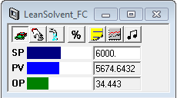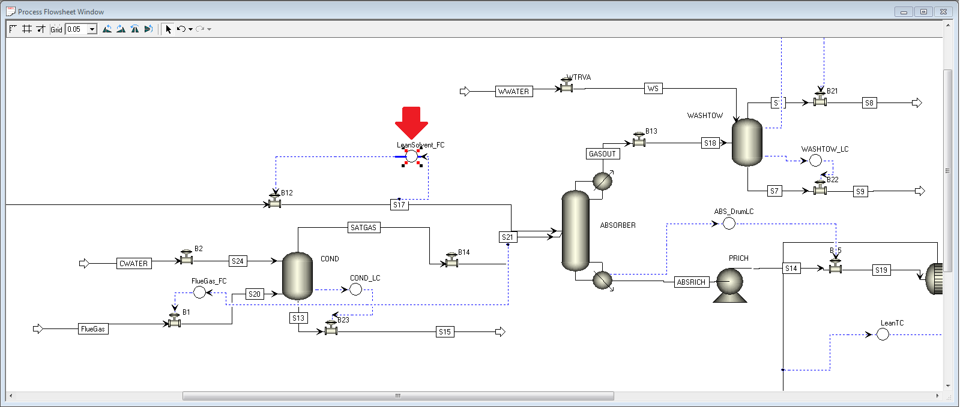

Figure : “LeanSolvent_FC” configuration window.

1. On the configuration window:
   1. Make sure the controller is in “auto-mode” as illustrated in Figure 40.
   2. Set “SP” to be “6000 kg/h.”
2. In the “Contents of Simulation” pane, located in the left side of the window, double-click “Flowsheet,” a new list of local files and options displays. Double-click the “Lean_Solvent” Form. Figure 41 illustrates this step.

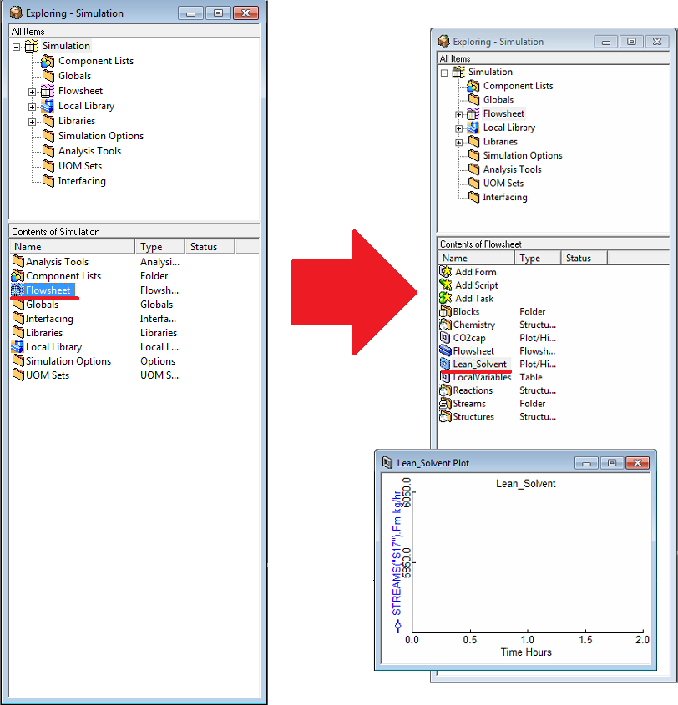

Figure : Opening a form.

1. Double-click the “x-axis” of the plot to open a configuration window that shows the axis properties. The default value for the time window is 2 hours, change it to “8.”
2. On the toolbar, click “Run Options,” as highlighted in red in Figure 42. Under “Simulation control,” change the “Pause at” value to “8” hours, which should be adequate to reach a new steady-state. This feature is very useful to introduce new step changes in the model, or to simply end the simulation at a given time.

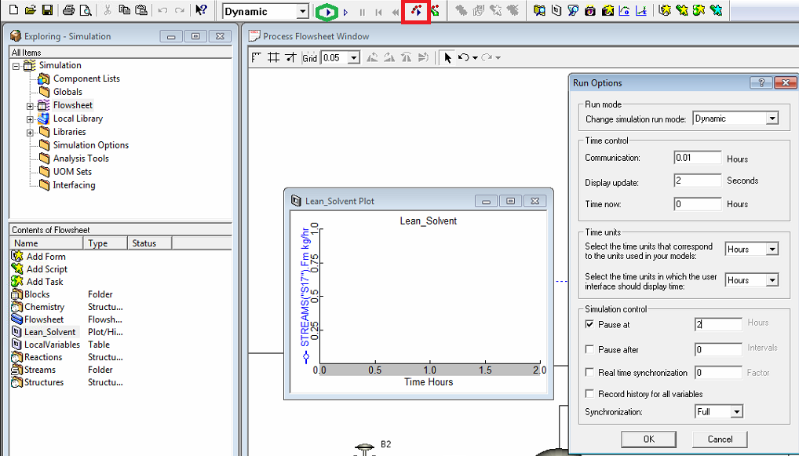

Figure : Run options.

1. Run the simulation by clicking “Play” as highlighted in green in Figure 43. The “Lean_Solvent” window records the behavior of the variable during the simulation. A plot similar to Figure 44 is expected. Figure 45 is a magnified version of the plot in Figure 44 showing the initial dynamics of the process.



Figure : Lean solvent flowrate behavior during step change to a new steady-state.



Figure : Lean solvent flowrate behavior during step change to a new steady-state (0.5 h).

* 1. CO2 Capture Dynamic Response Simulation

After a desired steady-state is reached, a number of step changes can be introduced to the system. In the beginning of this simulation, the lean solvent flowrate is at 5674 kg/h, which is the default lean amine flowrate when the file is opened.

1. Open the “CCSI_MEAModel_dynamic.dynf” file.
2. In the “Contents of Simulation” pane, located in the left side of the window, double-click “Flowsheet,” a new list of local files and options displays. Double-click “Lean_Solvent” Form and change the x-axis time window to “2” hours.
3. Repeat Step 2 for the “CO2 capture” Form.
4. On the toolbar, click “Run Options,” as highlighted in red in Figure 42. Under “Simulation control,” change the “Pause at” value to “0.50” hours.
5. Run the simulation until it is paused.
6. In the “Process Flowsheet Window,” double-click the controller “LeanSolvent_FC” to open the controller configuration window and then set “SP” to “6000.”
7. On the toolbar, click “Run Options,” as highlighted in red in Figure 42. Under “Simulation control,” change the “Pause at” value to “1.0” hours.
8. Run the simulation until it is paused.
9. In the “Process Flowsheet Window,” double-click the controller “LeanSolvent_FC” to open the controller configuration window and then set “SP” to “5674.”
10. On the toolbar, click “Run Options,” as highlighted in red in Figure 42. Under “Simulation control,” change the “Pause at” value to “1.5” hours.
11. Run the simulation until it is paused. Results similar to Figures 45 and 46 are expected.



Figure : Lean solvent flowrate into absorber.



Figure : CO2 capture percentage.

1. Reference

1. Zhang, Qiang; Turton, Richard; Bhattacharyya, Debangsu. Modeling and model predictive control of a MEA-based post-combustion CO2 capture process. Review Submitted, *Industrial & Engineering Chemistry* Research, 2015.

2. Morgan, J.C.; Bhattacharyya, D.; Tong, C.; Miller, D.C., Uncertainty Quantification of Property Models: Methodology and its Application to CO2-Loaded Aqueous MEA Solutions. *AIChE Journal* 2015, 61, 1822-1839.

3. Plaza, J.M. Modeling of Carbon Dioxide Absorption Using Aqueous Monoethanolamine, Piperazine, and Promoted Potassium Carbonate. PhD Thesis, The University of Texas at Austin, 2012.

4. Mathias, P.M.; Gilmartin, J.P., Quantitative Evaluation of the Effect of Uncertainty in Property Models on the Simulated Performance of Solvent-Based CO2 Capture. *Energy Procedia* 2014, 63, 1171-1185.